NAME : MOHAMMED FAZIL
ASSIGNMENT 3 DATA TRANSFORMATION AND DATA MODELING

● Import “List of Orders.csv” into Power BI.
Go to get data and click text/csv and import into the power bi
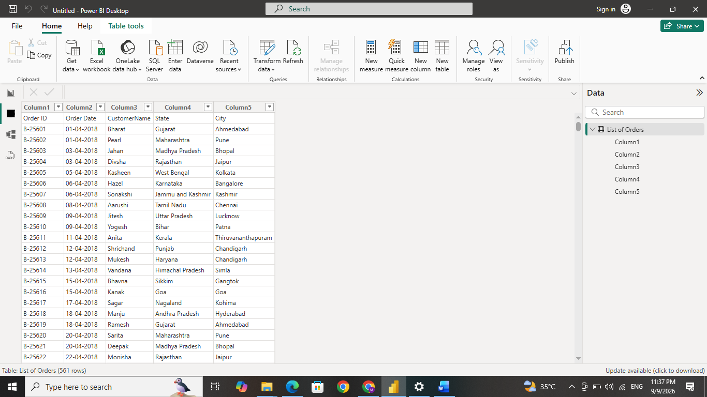

● Open “List of Orders” in Power Query Editor by clicking on ‘Transform’.
Click transform data in the queries section of the home ribbon to open the Power Query Editor. Alternatively, we can open the Power Query Editor directly by selecting Transform Data while importing the data.
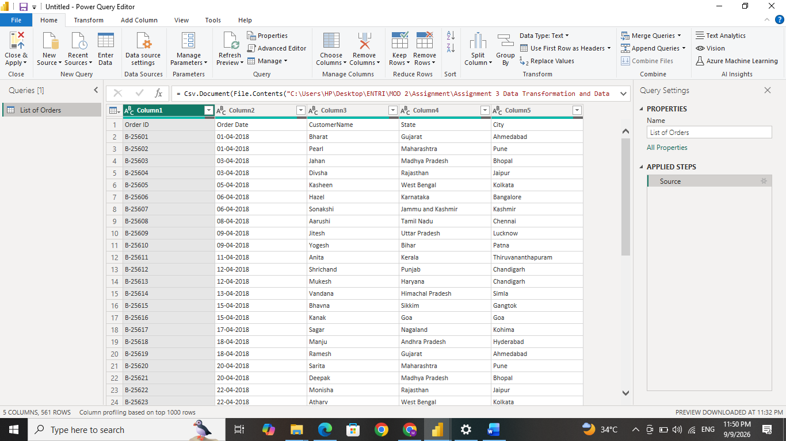

● Import “Order Details.csv” and “Sales target.csv” into Power Query Editor.
Click on new source and select text/csv
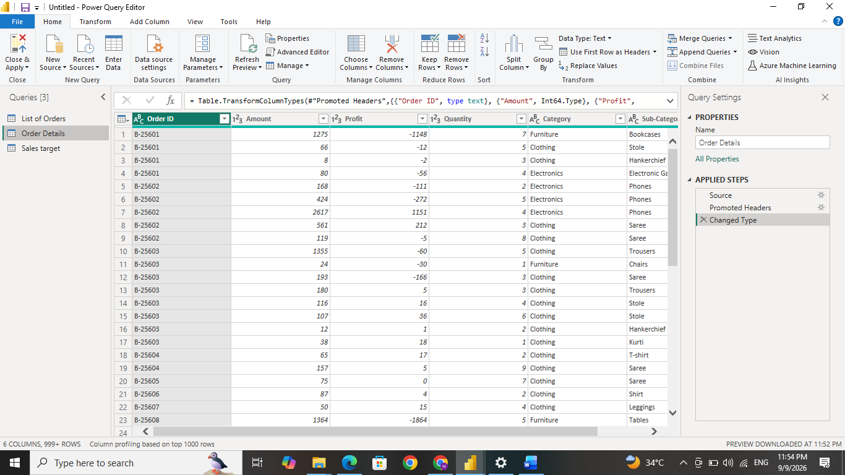

● Restrict the "List of Orders" table to only the first 500 rows.
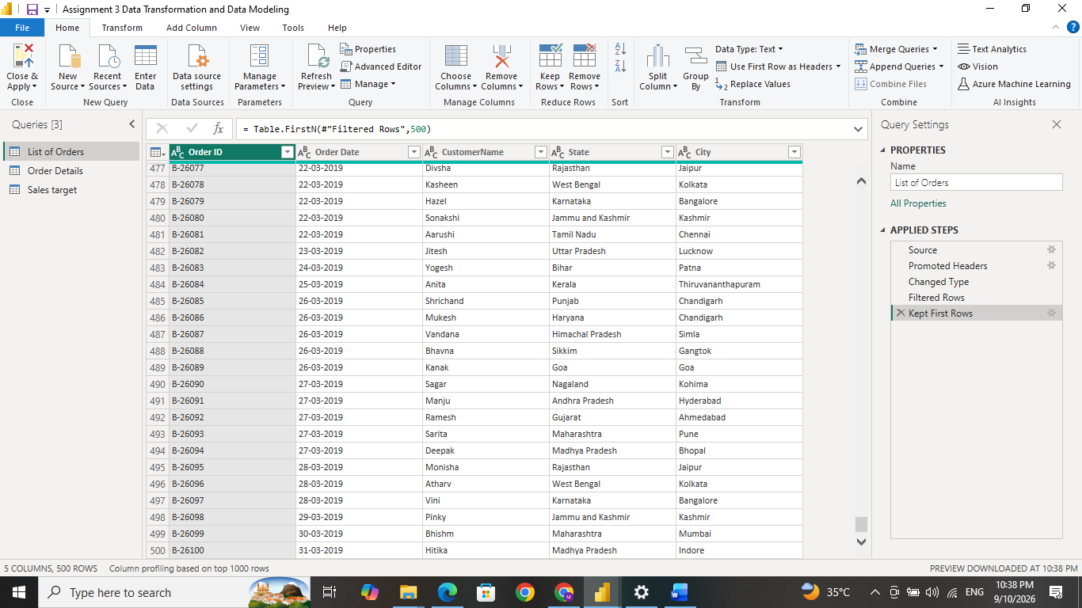
Go to Home tab and click keep rows in reduce rows ribbon and select how many rows we need to restrict. Here we restrict 500 rows in “List of Orders” table.

● Ensure the “Order Date” column in the “List of Orders” table is set to data type 'Date'.
click on the column heading of the Order Date and chance the data type to date with locale
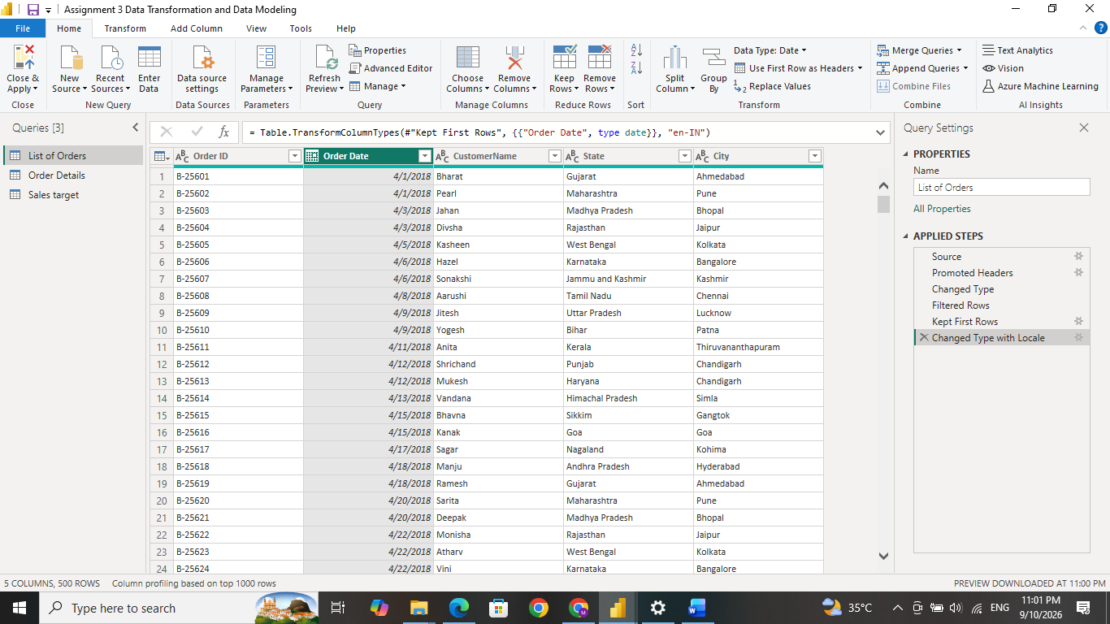

● Change the data type of “Amount” and “Target” columns to ‘Fixed Decimal Number’.
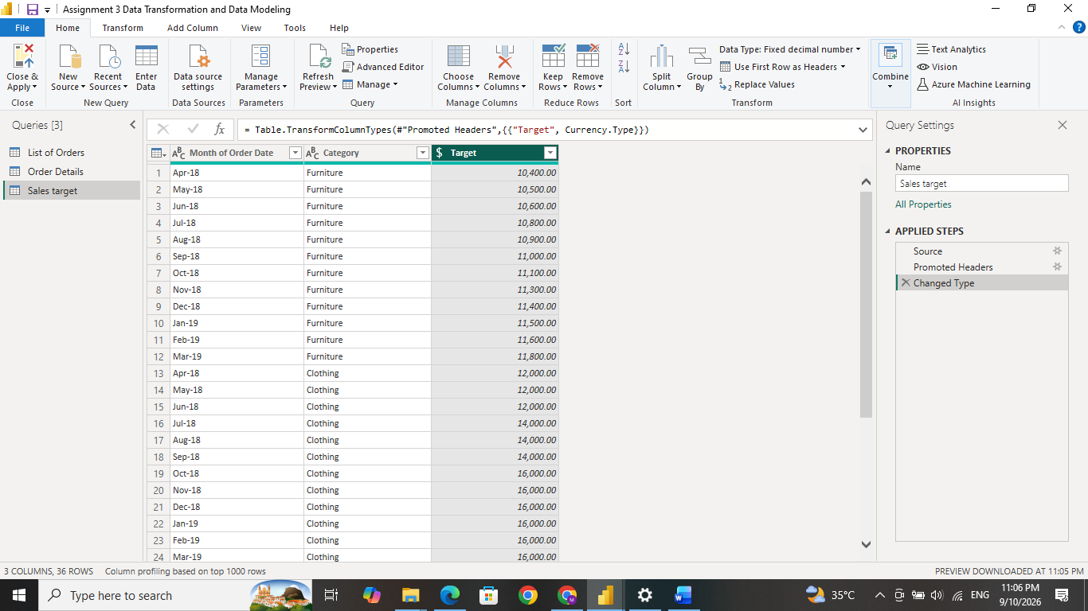
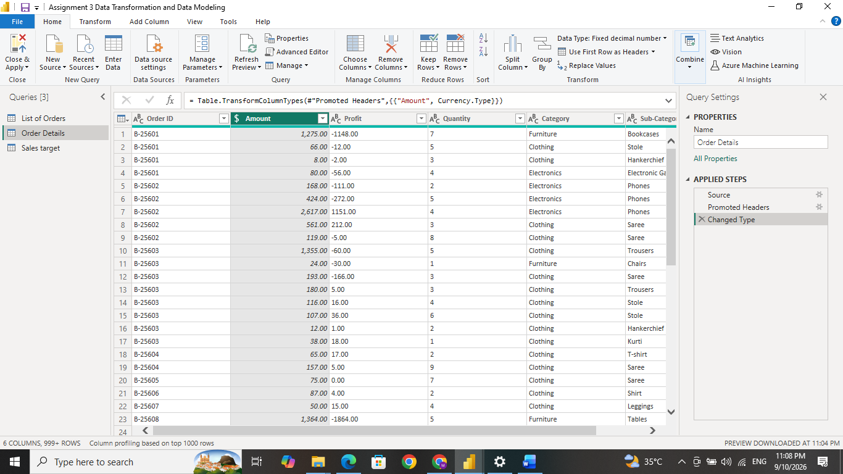

As same as above, click on the column heading and chance the data type to fixed decimal number on these columns in ‘Order Details’ table & ‘Sales target’ table.

● Format the "CustomerName" column into proper case, ensuring consistent capitalization for each word.
Select the column and go to transform. In Format option, click on Capitalize Each Word. This converts names into proper case.
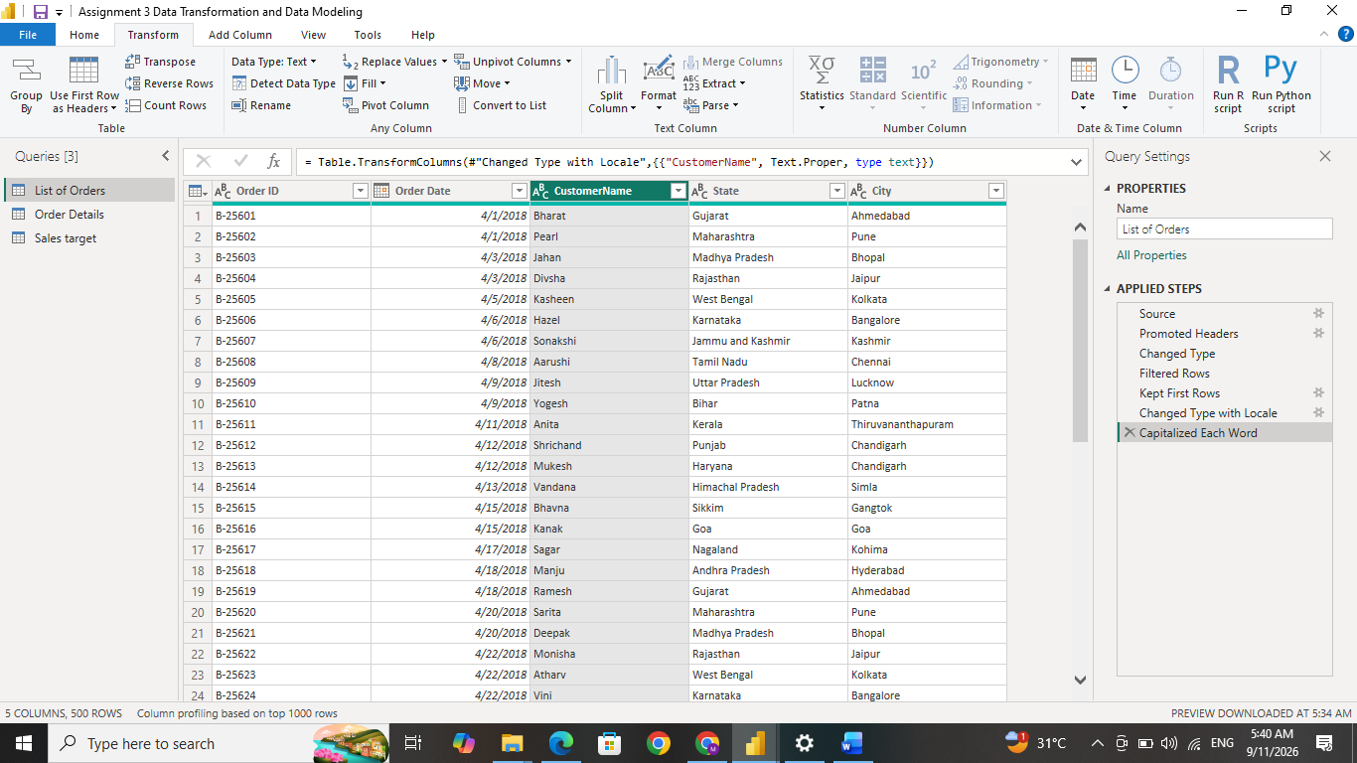

● Merge the "State" and "City" columns to create a new column named "Location" in the format ‘City, State’.
Select the city and state column. Go to transform and click merge column on From Text ribbon. Select the separator as comma and give the column name as Location.
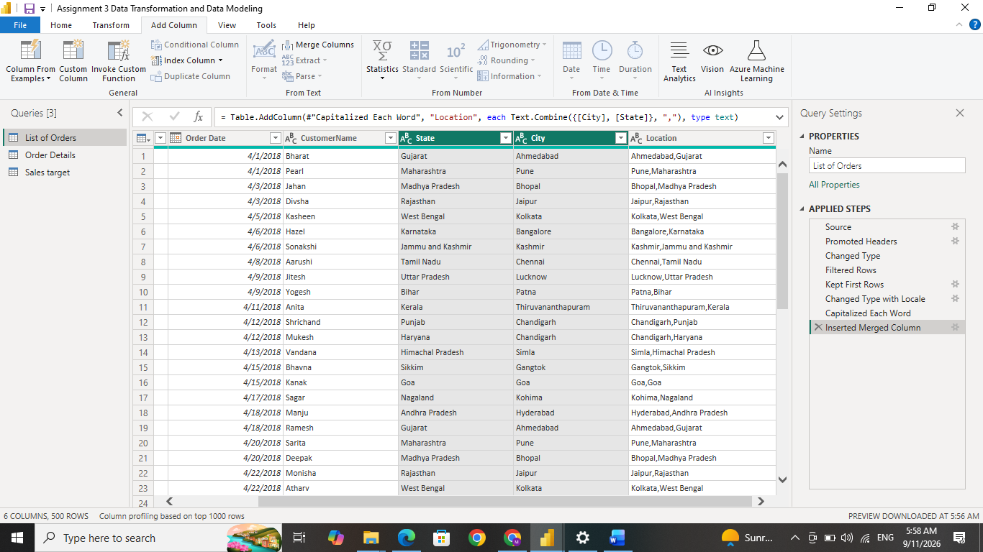

● Create a new custom column named "Profit Margin" as the percentage of "Profit" divided by "Amount".
Change the datatype of profit column and then go to add column and click on custom column. Give the new column name as Profit Margin and give the formula to calculate. = [Profit]/[Amount], then changed the column datatype to percentage.
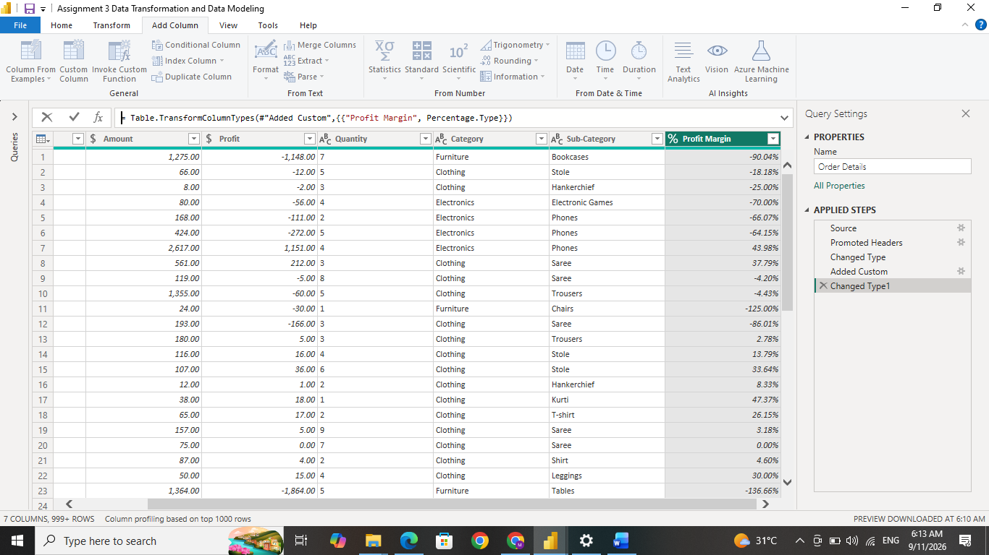

● Add a new conditional column named "Profit Status" based on the values in the "Profit" column. The conditions are as follows: if the profit is less than 0, the label should be "Loss"; if the profit equals 0, the label should be "Break-Even"; and if the profit is greater than 0, the label should be "Profit".
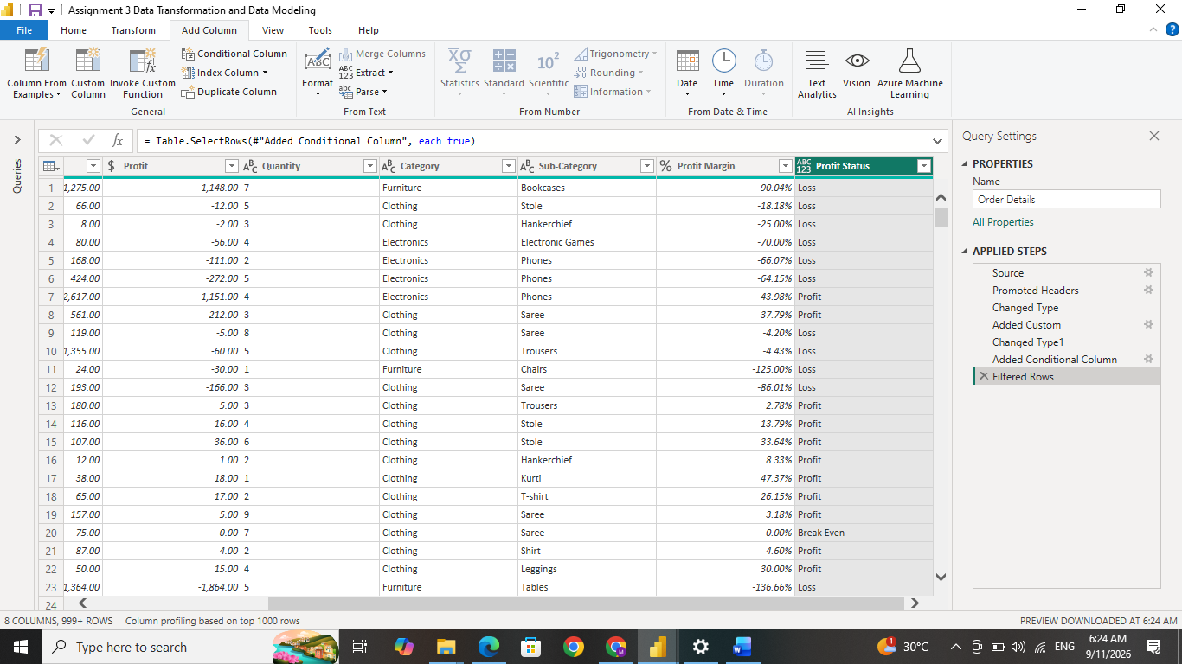
Here we go to add column and click on conditional column and enter Profile Status as the new column name. Set the condition rules as given below. This will show as profit or loss or break even in new column
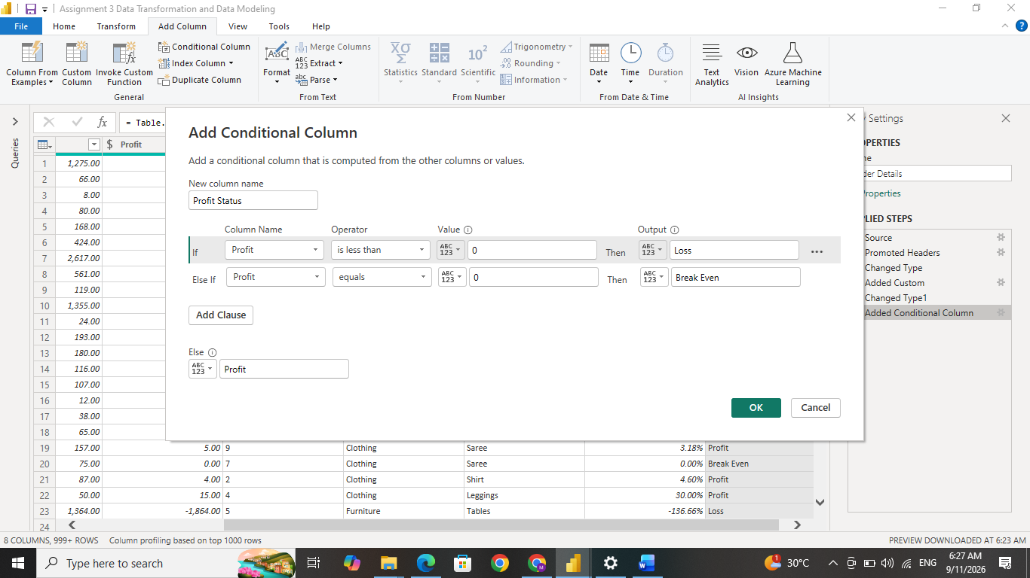
● Merge the "List of Orders" and "Order Details" tables into a new single table named "Orders Data" based on the "Order ID" relationship.

In home tab, go to combine ribbon and click merge queries and inside that click the merge queries as new. Then select the table and mark the column which is identical in both tables and select the Left Outer joint. This will combine both tables into new one.
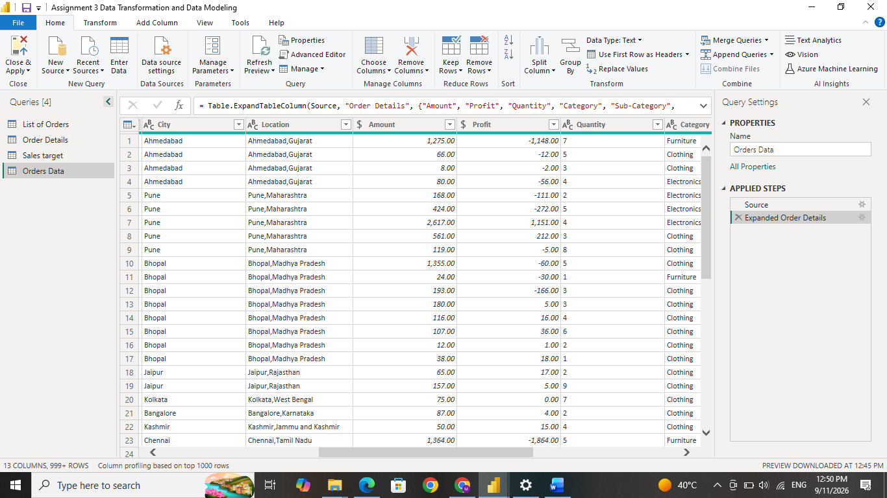

● Identify missing values in the data and determine a strategy to address them.
There were no missing values identified in the tables. The data was checked for missing values using Column indicator in Power Query which shows no error. so no replacement was required.
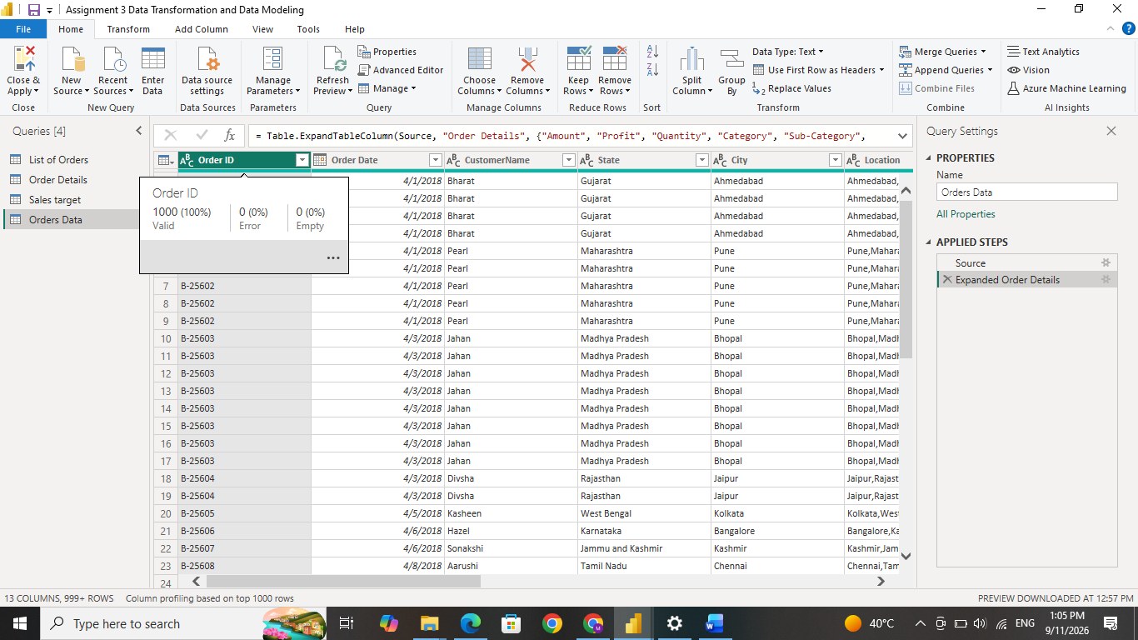

● Check for duplicate rows and define a strategy to handle duplicates.

